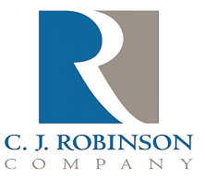
PO Box 217
East Greenville, PA 18041

Phone: (215) 679-3970
Fax: (215) 679-3761
Website: http://www.cjrobinson.com

Organo Tin Statement

To Whom It May Concern,

C.J. Robinson Co., Inc. Inc. certifies that none of its paraffin wax, oil or petrolatum products contain, nor come into contact with organo tins, specifically Mono-, Di-, Tri- or Tetra-Butyl Tins

Gary Barnes
C.J. Robinson Regulatory Issues

