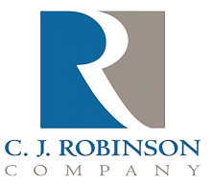
PO Box 217
East Greenville, PA 18041

Phone: (215) 679-3970
Fax: (215) 679-3761
Website: http://www.cjrobinson.com

CONEG Certification

To Whom It May Concern,

C.J. Robinson Co. Inc. certifies that none of paraffin wax, oil or petrolatum products contain nor come into contact with detectable levels of heavy metals covered by CONEG (Coalition Of North Eastern Governors).

Thus, they do not contain a combined concentration of total lead, hexavalent chromium, cadmium, or mercury of 100 or more milligrams per kilogram aka 100ppm.

Gary Barnes
C.J. Robinson Regulatory Issues

