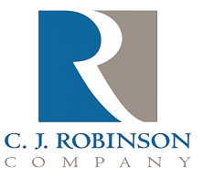
PO Box 217
East Greenville, PA 18041

Phone: (215) 679-3970
Fax: (215) 679-3761
Website: http://www.cjrobinson.com

ITX Statement

To Whom It May Concern,

C.J. Robinson Co., Inc. certifies that none of its paraffin wax, oil or petrolatum products contain nor comes into contact with isopropyl thioxanone, known by its acronym ITX.

Gary Barnes
C.J. Robinson Regulatory Issues

