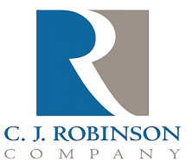
PO Box 217
East Greenville, PA 18041

Phone: (215) 679-3970
Fax: (215) 679-3761
Website: http://www.cjrobinson.com

Antioxidant Statement

To Whom It May Concern,

C.J. Robinson Co., Inc. and its suppliers of ingredients that makes up its’ paraffin wax, oil or petrolatum products utilizes antioxidants in some of these products.

BHA (Butylated Hydroxy Anisole) is not normally used.

BHT (Butylated Hydroxy Toluene) may be present in levels of up to 50 ppm

Gary Barnes
C.J. Robinson Regulatory Issues

